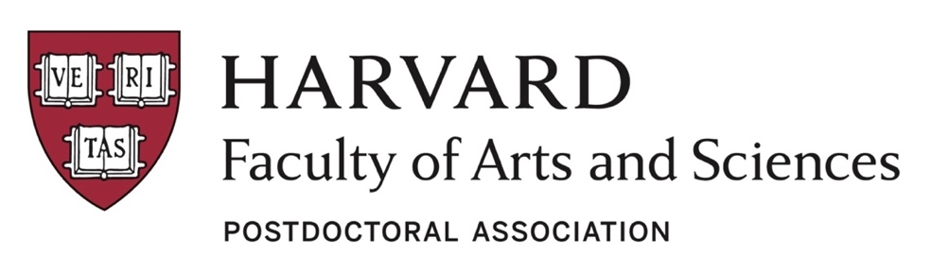
FAS Postdoc Association is looking for you!

Who are we?
The FAS Postdoc Association is a community for the postdocs of the Faculty of Arts and Sciences at Harvard University, Cambridge campus. We work closely with the FAS Postdoctoral Office to build community among postdocs and provide opportunities for professional growth and development.

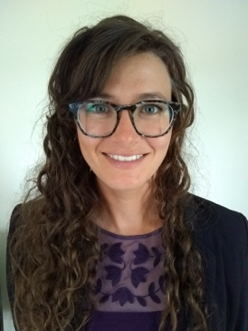 | Lindsay Hanford  President, Communications  Psychology  I am a postdoctoral fellow in the Buckner Laboratory, where I focus on making neuroimaging measures more reliable. I aim to better elucidate biological markers for mental health outcomes, and develop algorithms for individual assessment of disease risk, burden, and outcome. I am the FAS Postdoc Association President. This year I aim to help build a strong community among postdocs, and to enrich the postdoc experience by connecting people to opportunities for social and professional development.
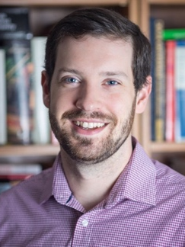 | Stephen Ferrigno  Vice President, Social Committee  Psychology  I am a postdoctoral fellow in the Lab for Developmental Studies. My work currently focusses on the evolutionary and developmental origins of human thought, specifically the representation of sequences and grammar. I am the vice president of the FAS Postdoc Association and am on the social committee. I work on organizing both on and off-campus outings and am always looking for fun new event ideas!
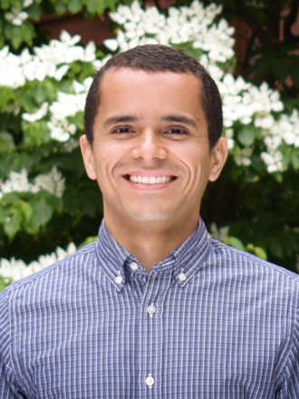 | Thiago Santos  Treasurer  Chemistry and Chemical Biology (CCB)  I work in the Department of Chemistry and Chemical Biology and the goal of my research is to elucidate the mechanistic details of protein assembly in the outer membrane of Gram-negative bacteria. I am a member of the finance committee of the FAS Postdoc Association, and the former president.
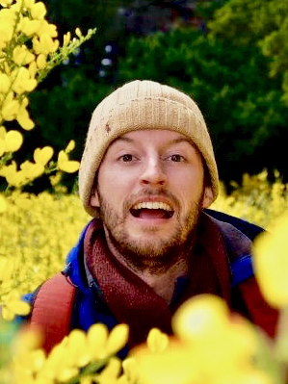 | Kyle McCulloch  Secretary/Chair  Organismic Evolutionary Biology (OEB)  I am fascinated by the evolution of the eye. The diversity of visual systems in the animal world is remarkable and I aim to understand common themes in their development and neurophysiology. Right now, I work with squid and sea anemones to understand the genetic building blocks that lead to photoreceptor cells. I am active in the careers committee in addition to being Secretary for the FAS Postdoc Association. I love being outdoors, and when not on campus you can find me hiking, running along the Charles River, lounging outside at a park, or at the beach.
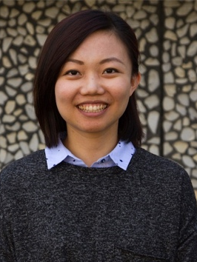 | Chrisy Xiyu Du  Advocacy  School of Engineering and Applied Sciences (SEAS)  I am a postdoctoral fellow in the John A. Paulson School of Engineering and Applied Sciences. I am interested in smartly design synthetic soft materials inspired by biology. I am a member of the advocacy committee of the FAS Postdoc Association. I work on the annual postdoc survey and help organize other Postdoc Association events. I am always looking for new ideas that can make the postdoc life at Harvard more enjoyable!
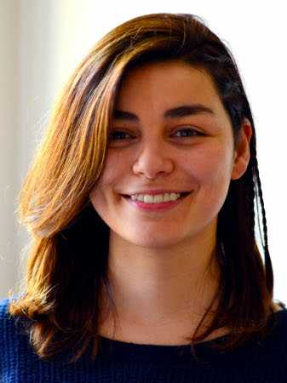 | Emine Kucukbenli  Advocacy/Careers  School of Engineering and Applied Sciences (SEAS)  I am a postdoctoral fellow in School of Engineering and Applied Sciences. My current research aims at accelerating materials modelling with neural networks and predicting properties of mixed-dimensional materials such as stacks of 2D materials and molecular crystals. As a part of Advocacy and Careers committees of FAS Postdoc Association, I contribute in activities that support researchers in developing skills to have a healthy work environment here at Harvard and building connections to make their next career step elsewhere. Focus of my efforts are unconscious bias towards women and minorities and software industry jobs for academics.
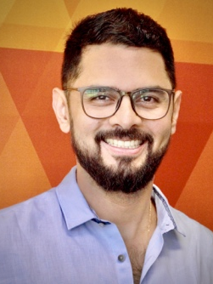 | Caio Frederico e Silva  Advocacy  Organismic Evolutionary Biology (OEB)  I am a Visiting Scholar linked by the Organismic Evolutionary Biology Department at the Harvard Herbaria in partnership with the Graduate School of Design (GSD). My work currently concentrates on investigating the relationship between climate change, sustainability, and greenery. I work at the Critical Landscapes Design Lab place on the GSD. I joined the FAS Postdoc Association to build cross-disciplinary collaborations and help to create a pleasant environment for all Postdocs.
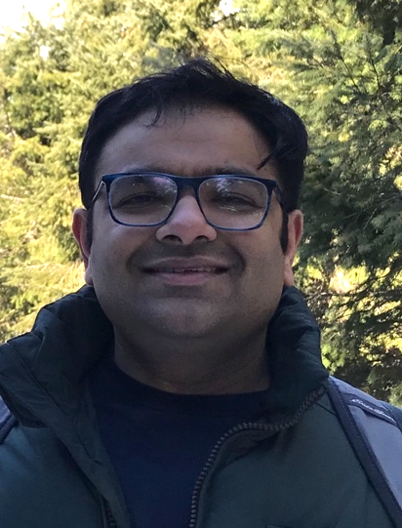 | Viral Shah  Advocacy  School of Engineering and Applied Sciences (SEAS)  I am a postdoc in Environmental Engineering and Science. My research is the area of atmospheric chemistry and focuses on the effect of human activities on air quality and climate. I joined the FAS Postdoc Association to work to advocate for the rights of postdocs to a safe and fulfilling working environment and to bring visibility to the contributions of postdocs in furthering Harvard’s academic and scholarly mission.
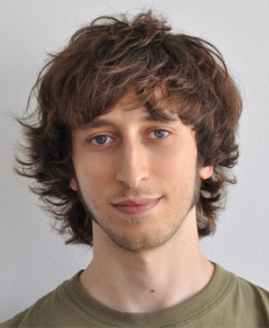 | Marco Fumasoni  Careers  Molecular and Cellular Biology (MCB)  I'm a postdoctoral fellow in the Murray lab studying genome evolution. I am part of the career committee in the FAS Postdoc Association, with the goal of helping other postdocs with their time at Harvard and afterwards.
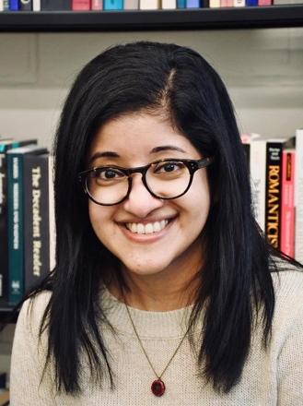 | Naina Kurup  Careers/Advocacy  Chemistry and Chemical Biology  I am a postdoctoral fellow in the Zhuang lab, and my work focuses on elucidating neuronal ultrastructure using super resolution microscopy techniques. As a member of the FAS Postdoc Association, and former Vice President, I have been working toward understanding the needs of the community and organizing events to enhance the postdoc experience at Harvard.
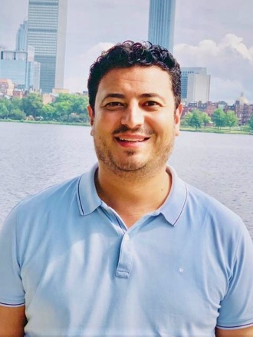 | Haitham Shaban  Careers  Center for Advanced Imaging at Harvard  I am a postdoctoral fellow in the center for advanced imaging. My research focuses on developing and using super-resolution microscopy, single molecule imaging, gene editing, and physical polymer modelling approaches for understanding the nuclear organization and gene regulation of the human genome.  At the moment, I am writing different grant applications and as I am a part of the career committee in the FAS Postdoc Association, I can share and help other postdocs for professional development.
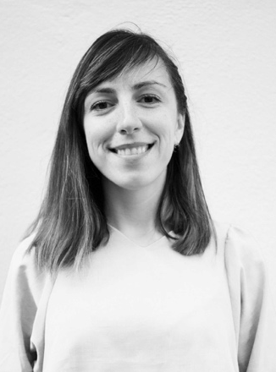 | Cristina Benea  Communications/Advocacy  School of Engineering and Applied Sciences (SEAS)  I am a postdoctoral fellow in the School of Engineering and Applied Sciences. My current work focusses on tunable metasurfaces with applications in fundamental studies and in industry. I am part of the communications and advocacy committees and my main interest is to give postdocs a voice and create an active community in which they can address their needs and concerns.
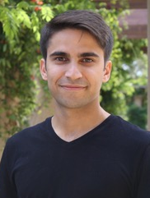 | Masoud Jafarali Jasbi  Social/Advocacy  Psychology  I am a postdoctoral fellow in linguistics and psychology. I study how humans develop language and logical thought. I am part of the social and advocacy committees, and I would like to help FAS Postdoc Association make the experience of being a postdoc at Harvard even more rewarding and fun.

What do we do?
We aim to fairly represent and advocate for the needs of the larger FAS postdoc community, and to enrich the postdoc experience by providing opportunities for social and professional development. This involves a wide range of topics and services that are dutifully taken care of by many volunteers. Help us to build a strong community and active association!

Join one of our committees:
Events - Do you like organizing scientific, social and career events? Join our events committee! We organize monthly happy hours, the postdoc science café, and social outings such as Brew at the Zoo.
Careers - Do you want to build a bridge between postdocs and industry? Perhaps better prepare yourself for a career in academic? Whatever your path, this committee helps organize events that provide tools for getting your ready for the job market.
Communication - Are you the source of news among your friends? Enjoy posting on Twitter, Facebook, LinkedIn? Join our communications team! Spread the word about our amazing events! Give postdocs a voice! Help us keep our postdoc community updated with the latest opportunities.
Advocacy - Is advocacy your thing? Help us share more information about the rights of postdocs at Harvard. Help us ask questions, and conduct surveys to understand the current postdoc climate. Help us make lasting change by joining the advocacy committee!

Many opportunities await you at the FAS Postdoc Association, and all kinds of contributions are welcome. We offer:
- An open-minded environment where you can learn how to manage a team
- Polish your organizational talent: organize workshops, panel discussions, or welcome events
- Make new lasting friendships: get to know fellow postdocs and maybe you’ll become friends for life!
- Take responsibility: we offer you visibility and freedom to sustain the association in many different ways
- The place to be creative: Have you always wanted to organize a book club? Boardgame night? … we can help you do that!

Our active and fun team is looking forward to hearing from you! Email us at faspda@fas.harvard.edu and one of our board members will get in touch with you!

Stay Connected!
SLACK: https://fas-pda.slack.com
Events Calendar: https://postdoc.harvard.edu/calendar/upcoming

