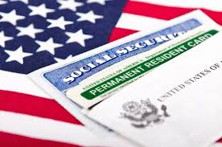

  - SPONSORED BY THE
  - FAS OFFICE OF POSTDOCTORAL AFFAIRS AND
  - HARVARD INTERNATIONAL OFFICE

GREEN CARDS, ENTREPRENEURSHIP AND WORK VISAS:

WHAT DO I NEED TO KNOW?

THURSDAY, NOVEMBER 7TH, 2017

1:00 – 3:00 PM

THE SCIENCE CENTER

HALL A
JOIN LOCAL IMMIGRATION ATTORNEYS FROM
COSTA & RICCIO, LLP
TO SPEAK ABOUT TOPICS SUCH AS H-1Bs, TNs, O-1s, ENTREPRENEURSHIP, GREEN CARDS AND MUCH MORE.
Q & A TO FOLLOW

